

Name: Lubinda Nawa

Student ID: 19141709

Course: Introduction To

Computer Systems

Lecturer: Tracey Chisanga

Assignment Number: 1

**ASSIGNMENT FROM UNIT 7**

1. List and explain any 5 use case of RAM drives.
2. **Gaming**: When running a game on a PC, the gameis loaded into RAM. RAMis used instead of the hard drive directly because it's faster and intended to store temporary items.
3. **Booting:**  RAM can have a noticeable effect on a computers startup speed as it improves communication speed with the processor and decrease load times.
4. **Running applications:** Any application that is executed is mounted into the ram. The greater the ram the more applications can run on it.
5. **3-D RENDERING**: To speed up rendering process.
6. **PERFORMING MATHEMATICAL CALCULATIONS.**

2. With the aid of a diagram describe the following RAID Levels giving one (**1**) advantages and one (**1**) Disadvantages for each

1. RAID 0

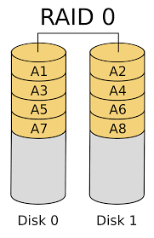

**Pro:** Faster write performance as compared to one drive.

**Con:** If one drive dies, then all memory is lost as it is treated as one drive.

1. RAID 1

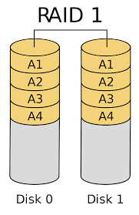**Pro:** It is reliable as data is duplicated on both drives hence data is not lost when one drive fails.

**Con:** Total memory is not combined but and hence Space available isn’t at full potential.

1. RAID 5

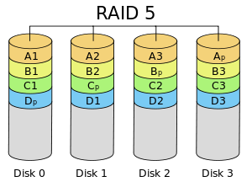**Pro:** Has distributed parity that acts as back up when one drive dies, as it is able to reconstruct lost data.

**Con:** Disk parity use ¼ of space therefore reducing overall usable disk space.

1. RAID 10(1+0)

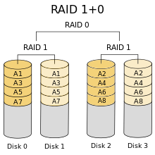**Pro:** Data is Duplicated which protects the drives from data loss.

**Con:** Space is lost at the cost of Security of data.

# References

**RAID O IMG-** <https://commons.wikimedia.org/wiki/File:RAID_0.svg>

**RAID 1 IMG-** <https://commons.wikimedia.org/wiki/File:RAID_1.svg>

**RAID 5 IMG-** <https://commons.wikimedia.org/wiki/File:RAID_5.svg>

**RAID 10 IMG -** <https://commons.wikimedia.org/wiki/File:RAID_5.svg>